Online Car Rental Services

Project Report Submitted in Partial Fulfilment of the Requirements for the Degree of

**Bachelor of Engineering**

***in***

**Computer Science and Engineering**

*Submitted by*

Krishna Kumari: (Roll No. 19UCSE4027)

Vinod Tak: (19UCSE4020)

***Under the Supervision of***

Simran Choudhary

Assistant Professor

**

Department of Computer Science and Engineering  
MBM University, Jodhpur

**July, 2022**

Online Car Rental Services

Training Report Submitted in Partial Fulfilment of the Requirements for the Degree of

**Bachelor of Engineering**

***in***

**Computer Science and Engineering**

*Submitted by*

Krishna Kumari: (Roll No. 19UCSE4027)

Vinod Tak: (Roll No. 19UCSE4020)

***Under the Supervision of***

Simran Choudhary

Assistant Professor

**

Department of Computer Science and Engineering

MBM University, Jodhpur

**July, 2022**

**Department of Computer Science & Engineering**

**MBM University**

**Ratanada, Jodhpur, Rajasthan, India –342011**



**CERTIFICATE**

This is to certify that the work contained in this seminar entitled **“Car Rental Services”** is submitted by the group members Ms. Krishna Kumari (Roll. No: 19UCSE4027), Mr.Vinod Tak (Roll No. 19UCSE4020) to the Department of Computer Science & Engineering, MBM University, Jodhpur, for the partial fulfilment of the requirements for the degree of **Bachelor of Engineering** in **Computer Science and Engineering.**

They have carried out their work under my supervision. This work has not been submitted elsewhere for the award of any other degree or diploma.

The project work in our opinion, has reached the standard fulfilling of the requirements for the degree of Bachelor of Engineering in Computer Science and engineering in accordance with the regulations of the Institute.

**Simran Choudhary**

**Assistant Professor**

**(Supervisor)**

Dept. of Computer Science & Engineering.

MBM University, Jodhpur

**DECLARATION**

We, ***Krishna Kumari, Vinod Tak***hereby declare that this work titled **“Online Car Rental Services”** is a record of original work done by us under the supervision and guidance of ***Simran Choudhary, Assistant Professor (Supervisor).***

We, further certify that this work has not formed the basis for the award of the Degree/Diploma/Associateship/Fellowship or similar recognition to any candidate of any university and no part of this report is reproduced as it is from any other source without appropriate reference and permission.

SIGNATURE OF STUDENT

**Krishna Kumari**

**8th Semester, CSE**

Enroll. – 18R/06186

Roll No. – 19UCSE4027

**Vinod Tak**

**8th Semester, CSE**

Roll No. – 19UCSE4020

**ACKNOWLEDGEMENT**

We, Krishna Kumari and Vinod Tak, would sincerely like to thank Dr. Nemi Chand Barwar, Head of Department, Computer Science & Engineering, MBM University, Jodhpur for the support and availability of facilities by the department. We wish to express our deepest sense of gratitude to Asst. Prof. Simran Choudhary, for her able guidance and useful suggestions that helped us in completing the project work, on time. Her guidance, encouragement, suggestion, and constructive criticism have contributed immensely to the evolution of our ideas on the report.

Finally, yet most importantly, We would like to express our heartfelt thanks to our family, friends, and peers for their blessings, wishes, and support for the successful completion of this report.

**ABSTRACT**

The project is designed to help people utilize transport effectively. In recent times cars have become most convenient modes of transportation. Our Car rental system helps in making this an easier, hassle-free and enjoyable experience to acquire and use a car as per ones needs. A car rental is a vehicle that can be used temporarily for a period of time with a fee. Renting a car assists people to get around even when they do not have access to their own personal vehicle or don't own a vehicle at all. A person can book a car specifically for his travel time, co-travellers and the nature of travel. The rental system traverses from designing a database to understanding business concept and above all to make this an easy to adapt system for various travelling needs.

**Contents**

|  |  |
| --- | --- |
| 1. **Introduction** | **1** |
| * 1. Overview.……… ………………………………………........      1. Reasons for the project...................................................   2. Problem Statement....................................................................   3. Aim and Objective....................................................................   4. Scope........................................................................................   5. How car rental services work...................................................   6. Benefits of Online Car rental services...................................... | **1**  **2**  **2**  **3**  **3**  **3**  **4** |
| 1. **Technology Used**    1. HTML.........................................................................................    2. CSS............................................................................................    3. Bootstrap....................................................................................    4. JavaScript...................................................................................    5. PHP............................................................................................    6. MySQL.......................................................................................    7. Apache......................................................................................... | **5**  **5**  **6**  **7**  **8**  **9**  **10**  **11**  **11** |
| 1. **Project/Work Details**    1. Modules of the project.................................................................    2. Admin, User and Characteristics..................................................       1. Admin..................................................................................       2. User.......................................................................................    3. Scope...............................................................................................    4. Conceptual Design of Database.......................................................    5. Data Flow & UML Diagrams............................................................. | **12**  **12**  **13**  **13**  **13**  **14**  **15** |
| 1. **Results/Outcome** | **17** |
| 1. **Conclusion & Future Work**    1. Conclusion...........................................................................................    2. Future Work......................................................................................... | **22**  **22**  **22** |
| **References……………………………………………………………………..** | **23** |

**List of Figures**

|  |  |
| --- | --- |
| 2.1. HTML...............…………………………………………………………… | 5 |
| 2.2. CSS.................. ……………………………………………………………  2.3. Bootstrap......................................................................................................  2.4. JavaScript......................................................................................................  2.5. PHP...............................................................................................................  2.6. MySQL.........................................................................................................  2.7. Xampp..........................................................................................................  2.8. Apache.........................................................................................................  3.1. Level 0 DFD...............................................................................................  3.2. Use Case Diagram........................................................................................  4.1. Home Page....................................................................................................  4.2. Car Selection.................................................................................................  4.3. Login.............................................................................................................  4.4. Register & Login..........................................................................................  4.5. Sign Up.........................................................................................................  4.6. Admin Panel................................................................................................. | 6  7  8  9  10  11  11  15  16  17  18  19  20  20  21 |

**Chapter 1**

**INTRODUCTION**

Transportation is one of major issue which is affecting day to day life of people. Roadways traffic is one of the most commonly used network for moving from one place to another place .In road traffic the majority of road transport consists of the single passenger car. These private cars are mostly used with only a single ride for single person. Since increased traffic causes pollution, traffic jam, time wastage ,more parking space is needed and many more other issues. In modern day world there are numbers of applications.

This project is designed so as to be used by Car Rental Company specializing in renting cars to customers. It is an online system through which customers can view available cars, register, view profile and book car. A car rental is a vehicle that can be used temporarily for a period of time with a fee. Renting a car assists people to get around even when they do not have access to their own personal vehicle or don't own a vehicle at all. The individual who want to rent a car must first contact the car rental company for the desire vehicle. This can be done online. At this point, this person has to supply some information such as; dates of rental, and type of car. After these details are worked out, the individual renting the car must present a valid Identification Card.

* 1. **Overview**

This project is designed so as to be used by Car Rental Company specializing in renting cars to customers. It is an online system through which customers can view available cars, register, view profile and book car.

**1.1.1 Reasons for the project**

The advancement in Information Technology and internet penetration has greatly enhanced various business processes and communication between companies (services provider) and their customers of which car rental industry is not left out. This E-Car Rental System is developed to provide the following services:

1. Enhance Business Processes: To be able to use internet technology to project the rental company to the global world instead of limiting their services to their local domain alone, thus increase their return on investment (ROI).
2. Online Vehicle Reservation: A tools through which customers can reserve available cars online prior to their expected pick-up date or time.
3. Customer’s registration: A registration portal to hold customer’s details, monitor their transaction and used same to offer better and improve services to them.
   1. **Problem Statement**

As we live in a modern day world where people tend to prefer their own vehicle on road for each and every small work. In recent years the no of vehicles on the road has increased tremendously which has created the problem of traffic on the roads. As the numbers of vehicles on the roads are increasing it give rise to many problems such as increase in pollution level of nearby surroundings. More the number of vehicles on the road more will be the fuel consumption which leads to hike in prices of fuel prices are they are non renewable resource of energy. Pollution from these vehicles also has adverse effects on the health of people so car rental system is a solution but it has certain challenges and issues like security and trust issues. A car rental is a vehicle that can be used temporarily for a fee during a specified period. Getting a rental car helps people get around despite the fact they do not have access to their own personal vehicle or don't own a vehicle at all. The individual who needs a car must contact a rental car company and contract out for a vehicle. This system increases customer retention and simplify vehicle and staff management.

**1.3 Aims And Objectives**

 To produce a web-based system that allow customer to register and reserve car online and for the company to effectively manage their car rental business.  To ease customer’s task whenever they need to rent a car.

**1.4 Scope**

This project traverses a lot of areas ranging from business concept to computing field, and required to perform several researches to be able to achieve the project objectives. The area covers include:

1. Car rental industry: This includes study on how the car rental business is being done, process involved and opportunity that exist for improvement.
2. PHP Technology used for the development of the application.
3. General customers as well as the company’s staff will be able to use the system effectively.
4. Web-platform means that the system will be available for access 24/7 except when there is a temporary server issue which is expected to be minimal.
   1. **How Car Rental Services Work**

A car rental is a vehicle that can be used temporarily for a period of time with a fee. Renting a car assists people to get around even when they do not have access to their own personal vehicle or don't own a vehicle at all. The individual who want to rent a car must first contact the car rental company for the desire vehicle. This can be done online. At this point, this person has to supply some information such as; dates of rental, and type of car. After these details are worked out, the individual renting the car must present a valid Identification Card. Most companies throughout the industry make a profit based of the type of cars that are rented. The rental cars are categorized into economy, compact, compact premium, premium and luxury. And customers are free to choose any car of their choice based on their purse and availability of such car at the time of reservation.

* 1. **Benefits of Online Car Rental Services**
* This online car rental solution is fully functional and flexible.
* It is very easy to use.
* This online car rental system helps in back office administration by streamlining and standardizing the procedures.
* It saves a lot of time, money and labour.
* Eco-friendly: The monitoring of the vehicle activity and the overall business becomes easy and includes the least of paper work.
* The software acts as an office that is open 24/7.
* It increases the efficiency of the management at offering quality services to the customers.
* It provides custom features development and support with the software.

**Chapter 2**

**TECHNOLOGY USED**

Technologies that are generally used in the UI development of a web page are as follows:

1. HTML
2. CSS
3. Bootstrap
4. JavaScript
5. PHP
6. MySQL
7. XAMPP
8. APACHE

Let’s get into the detailing of each in the further section.

**2.1. HTML**



**Fig 2.1: HTML**

Hypertext Markup Language (HTML) is the standard mark-up language for creating web pages and web applications. With Cascading Style Sheets (CSS) and JavaScript it forms a triad of cornerstone technologies for the World Wide Web. Web browsers receive HTML documents from a web server or from local storage and render them into multimedia web pages. HTML describes the structure of a web page semantically and originally included cues for the appearance of the document.

HTML mark up consists of several key components, including those called tags (and their attributes), character-based data types, character references and entity references. HTML tags most commonly come in pairs like <h1> and </h1>, although some represent empty elements and so are unpaired, for example <img>. The first tag in such a pair is the start tag, and the second is the end tag (they are also called opening tags and closing tags).

Another important component is the HTML document type declaration, which triggers standards mode rendering.

**2.2. CSS**



**Fig 2.2: CSS**

Cascading Style Sheets (CSS) is a style sheet language used for describing the presentation of a document written in a mark up language. Although most often used to set the visual style of web pages and user interfaces written in HTML and XHTML, the language can be applied to any XML document, including plain XML, SVG and XUL, and is applicable to rendering in speech, or on other media. Along with HTML and JavaScript, CSS is a cornerstone technology used by most websites to create visually engaging web pages, user interfaces for web applications, and user interfaces for many mobile applications.

CSS is designed primarily to enable the separation of presentation and content, including aspects such as the layout, colours, and fonts. This separation can improve content accessibility, provide more flexibility and control in the specification of presentation characteristics, enable multiple HTML pages to share formatting by specifying the relevant CSS in a separate .css file, and reduce complexity and repetition in the structural content.

The CSS specifications are maintained by the World Wide Web Consortium (W3C). Internet media type (MIME type) text/css is registered for use with CSS by RFC 2318 (March) 1998). The W3C operates a free CSS validation service for CSS documents.

Types of CSS:

* **Inline CSS:**

In this CSS is applied in between the tags

* **Internal CSS:**

In this Thecss code is defined inside the style tag in the head section of the HTML page.

* **External CSS:**

In this the CSS code is written on another page and is linked to the HTML page. It is advantageous to use this type of styling as we can use the same file to style various HTML pages.-

**2.3. BOOTSTRAP**



**Fig 2.3: Bootstrap**

Bootstrap is a free and open-source front-end web framework for designing websites and web applications. It contains HTML and CSS-based design templates for typography, forms, buttons, navigation and other interface components, as well as optional JavaScript extensions. Unlike many web frameworks, it concerns itself with front-end development only.

Bootstrap is the second most-starred project on GitHub, with more than 107,000 stars and 48,000 forks.

Bootstrap, originally named Twitter Blueprint, was developed by Mark Otto and Jacob Thornton at Twitter as a framework to encourage consistency across internal tools. Before Bootstrap, various libraries were used for interface development, which led to inconsistencies and a high maintenance burden. According to twitter developer Mark Otto:

**2.4 JAVASCRIPT**



**Fig 2.4: JavaScript**

JavaScript, often abbreviated as "JS", is a high-level, dynamic, untyped, and interpreted run-time language. It has been standardized in the ECMAScript language specification. Alongside HTML and CSS, JavaScript is one of the three core technologies of World Wide Web content production; the majority of websites employ it, and all modern Web browsers support it without the need for plug-ins. JavaScript is prototype-based with first-class functions, making it a multi-paradigm language, supporting object-oriented, imperative, and functional programming styles. It has an API for working with text, arrays, dates and regular expressions, but does not include any I/O, such as networking, storage, or graphics facilities, relying for these upon the host environment in which it is embedded.

JavaScript is also used in environments that are not Web-based, such as PDF documents, site-specific browsers, and desktop widgets. Newer and faster JavaScript virtual machines (VMs) and platforms built upon them have also increased the popularity of JavaScript for server-side Web applications. On the client side, developers have traditionally implemented JavaScript as an interpreted language, but more recent browsers perform just-in-time compilation. Programmers also use JavaScript in video-game development, in crafting desktop and mobile applications, and in server-side network programming with run-time environments such as Node.js.

**2.5. PHP**



**Fig 2.5: PHP**

PHP is a [general-purpose](https://en.wikipedia.org/wiki/General-purpose_programming_language) [scripting language](https://en.wikipedia.org/wiki/Scripting_language) geared toward [web development](https://en.wikipedia.org/wiki/Web_development). It was originally created by Danish-Canadian [programmer](https://en.wikipedia.org/wiki/Programmer) [Rasmus Lerdorf](https://en.wikipedia.org/wiki/Rasmus_Lerdorf) in 1994. The PHP [reference implementation](https://en.wikipedia.org/wiki/Reference_implementation) is now produced by The PHP Group. PHP originally stood for Personal Home Page, but it now stands for the [recursive initialism](https://en.wikipedia.org/wiki/Recursive_initialism) PHP: Hypertext Pre-processor.

PHP code is usually processed on a [web server](https://en.wikipedia.org/wiki/Web_server) by a PHP [interpreter](https://en.wikipedia.org/wiki/Interpreter_(computing)) implemented as a [module](https://en.wikipedia.org/wiki/Plugin_(computing)), a [daemon](https://en.wikipedia.org/wiki/Daemon_(computing)) or as a [Common Gateway Interface](https://en.wikipedia.org/wiki/Common_Gateway_Interface) (CGI) executable. On a web server, the result of the [interpreted](https://en.wikipedia.org/wiki/Interpreter_(computing)) and executed PHP code – which may be any type of data, such as generated [HTML](https://en.wikipedia.org/wiki/HTML) or [binary](https://en.wikipedia.org/wiki/Binary_number) image data – would form the whole or part of an [HTTP](https://en.wikipedia.org/wiki/Hypertext_Transfer_Protocol) response. Various [web template systems](https://en.wikipedia.org/wiki/Web_template_system), web [content management systems](https://en.wikipedia.org/wiki/Content_management_system), and [web frameworks](https://en.wikipedia.org/wiki/Web_framework) exist which can be employed to orchestrate or facilitate the generation of that response. Additionally, PHP can be used for many programming tasks outside the web context, such as standalone [graphical applications](https://en.wikipedia.org/wiki/Graphical_user_interface) and [robotic](https://en.wikipedia.org/wiki/Robotics) [drone](https://en.wikipedia.org/wiki/Unmanned_aerial_vehicle) control. PHP code can also be directly executed from the [command line](https://en.wikipedia.org/wiki/Command-line_interface).

The standard PHP interpreter, powered by the [Zend Engine](https://en.wikipedia.org/wiki/Zend_Engine), is [free software](https://en.wikipedia.org/wiki/Free_software) released under the [PHP License](https://en.wikipedia.org/wiki/PHP_License). PHP has been widely ported and can be deployed on most web servers on a variety of [operating systems](https://en.wikipedia.org/wiki/Operating_system) and [platforms](https://en.wikipedia.org/wiki/Computing_platform).

The PHP language evolved without a written [formal specification](https://en.wikipedia.org/wiki/Formal_specification) or standard until 2014, with the original implementation acting as the [de facto](https://en.wikipedia.org/wiki/De_facto) standard which other implementations aimed to follow. Since 2014, work has gone on to create a formal PHP specification.

**2.6. MySQL**



**Fig 2.6: MySQL**

MySQL is an [open-source](https://en.wikipedia.org/wiki/Open-source_software) [relational database management system](https://en.wikipedia.org/wiki/Relational_database_management_system) (RDBMS). Its name is a combination of "My", the name of co-founder [Michael Widenius](https://en.wikipedia.org/wiki/Michael_Widenius)'s daughter,[[7]](https://en.wikipedia.org/wiki/MySQL#cite_note-7) and "[SQL](https://en.wikipedia.org/wiki/SQL)", the abbreviation for [Structured Query Language](https://en.wikipedia.org/wiki/Structured_Query_Language). A [relational database](https://en.wikipedia.org/wiki/Relational_database) organizes data into one or more data tables in which data may be related to each other; these relations help structure the data. SQL is a language programmers use to create, modify and extract data from the relational database, as well as control user access to the database. In addition to relational databases and SQL, an RDBMS like MySQL works with an [operating system](https://en.wikipedia.org/wiki/Operating_system) to implement a relational database in a computer's storage system, manages users, allows for network access and facilitates testing database integrity and creation of backups.

MySQL is [free and open-source software](https://en.wikipedia.org/wiki/Free_and_open-source_software) under the terms of the [GNU General Public License](https://en.wikipedia.org/wiki/GNU_General_Public_License), and is also available under a variety of [proprietary](https://en.wikipedia.org/wiki/Proprietary_software) licenses. MySQL was owned and sponsored by the [Swedish](https://en.wikipedia.org/wiki/Sweden) company [MySQL AB](https://en.wikipedia.org/wiki/MySQL_AB), which was bought by [Sun Microsystems](https://en.wikipedia.org/wiki/Sun_Microsystems) (now [Oracle Corporation](https://en.wikipedia.org/wiki/Oracle_Corporation)). In 2010, when Oracle acquired Sun, Widenius [forked](https://en.wikipedia.org/wiki/Fork_(software_development)) the [open-source](https://en.wikipedia.org/wiki/Open-source) MySQL project to create [MariaDB](https://en.wikipedia.org/wiki/MariaDB).

**2.7. XAMPP**



**Fig 2.7: XAMPP**

XAMPP  is a [free and open-source](https://en.wikipedia.org/wiki/Free_and_open-source) [cross-platform](https://en.wikipedia.org/wiki/Cross-platform) [web server](https://en.wikipedia.org/wiki/Web_server) [solution stack](https://en.wikipedia.org/wiki/Solution_stack) package developed by Apache Friends, consisting mainly of the [Apache HTTP Server](https://en.wikipedia.org/wiki/Apache_HTTP_Server), [MariaDB](https://en.wikipedia.org/wiki/MariaDB) [database](https://en.wikipedia.org/wiki/Database), and [interpreters](https://en.wikipedia.org/wiki/Interpreter_(computing)) for scripts written in the [PHP](https://en.wikipedia.org/wiki/PHP) and [Perl](https://en.wikipedia.org/wiki/Perl) [programming languages](https://en.wikipedia.org/wiki/Programming_language). Since most actual web server deployments use the same components as XAMPP, it makes transitioning from a local test server to a live server possible.

XAMPP's ease of deployment means a [WAMP](https://en.wikipedia.org/wiki/WAMP) or [LAMP](https://en.wikipedia.org/wiki/LAMP_(software_bundle)) stack can be installed quickly and simply on an operating system by a developer, with the advantage that common add-in applications such as [WordPress](https://en.wikipedia.org/wiki/WordPress) and [Joomla!](https://en.wikipedia.org/wiki/Joomla!) can also be installed with similar ease using [Bitnami](https://en.wikipedia.org/wiki/Bitnami).

**2.8. APACHE**



**Fig 2.8: APACHE**

[Apache](https://www.sumologic.com/application/apache/) HTTP Server is a free and open-source web server that delivers web content through the internet. It is commonly referred to as Apache and after development; it quickly became the most popular HTTP client on the web. It’s widely thought that Apache gets its name from its development history and process of improvement through applied patches and modules but that was corrected back in 2000. It was revealed that the name originated from the respect of the Native American tribe for its resiliency and durability.

**Chapter 3**

**PROJECT/WORK DETAILS**

The Car Rental System is the online facility to book cars online within few clicks only. Some people cannot afford to have a car, for those people this system becomes very helpful. This system includes various cars, as per the customer order and comfort, it place the order and deliver the car as per the location within the area. For travelling a long distance, booking can be done via internet service only.

Here, User has to Login To book a car. The user can search for cars easily and book. For bookings, the user has to provide information such as Booking Dates and Text Message. All car details are provided and it also includes Car’s feature and Overview. The user can also post their Testimonials and the user can update their Profile as well as passwords anytime they want from the site. Admin can Add/Manage car brands, manage vehicles, bookings, testimonial, pages and many more.  It’s easy to operate and understand by users. This site makes customers easy for car rental. The design is pretty simple and the user won’t find it difficult to understand, use and navigate.

**3.1. Modules of the Project**

* 1. Login/Register System.
  2. Easy Bookings
  3. Create/Manage Brands.
  4. Post/Manage Vehicle
  5. Manage Bookings, Testimonials, Contact Queries, Pages.

**3.2. Admin, Users and Characteristics**

3.2.1. Admin

* Admin can create vehicle brand
* Manage vehicle brand(Edit, Delete)
* Post vehicle
* Manage vehicle(Edit, Delete)
* Manage booking(Admin can confirm and cancel booking)
* Manage testimonials(Active and Inactive)
* Manage to contact us query
* Admin can view the details of registered users
* Admin can also update the page content
* Manage subscribers
* Admin dashboard(Admin can view the count of registered users, total bookings total subscribers, etc..)
* Change password
* Logout

3.2.2. User

* Car booking
* View car history
* Update his/her profile
* Post testimonials
* View testimonials
* Registration for new users
* Login
* Logout

**3.3. Scope**

* + 1. Providing car catalog to the Users so that they can choose the best option based on their concern.
    2. Admin can manage the catalog by adding or removing the cars based on their availability and allows only authorized Users (Driver License) to rent a vehicle.
    3. Admin must make sure that the rented cars must have valid insurance.
    4. Admin must allow user to provide feedback at the end of every ride.

**3.4. CONCEPTUAL DESIGN OF DATABASE**

Entity: Admin

Attributes:

username

password

Entity: Car

Attributes:

brand

price per day

fuel type

model year

Entity: Customer

Attributes:

Name

email_id

mobile _number

Date_of_birth

address [composite, multi-valued]

address_line_1

address_line_2

city

state

reg _date

Entity: Account

Attributes:

username

password

**3.6. Data Flow and UML Diagrams**

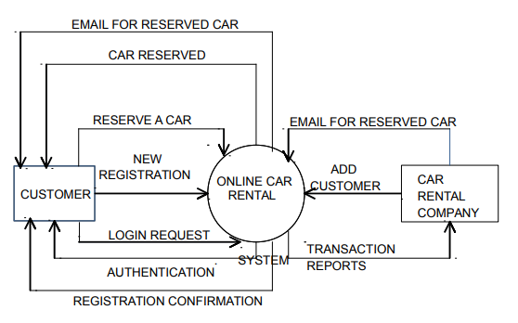

**Fig 3.1: Level 0 DFD**

In this diagram, Customer and Car Rental Company are the two entity sets.

Functions of Customer:

* New Registration
* Login Request
* Registration Confirmation by the System
* Reserve Car
* Car Issued by the System
* Email received for Reserved Car

Functions of Car Rental Company:

* Add Customer
* Send E-Mails for Reserved Car
* View Transaction report

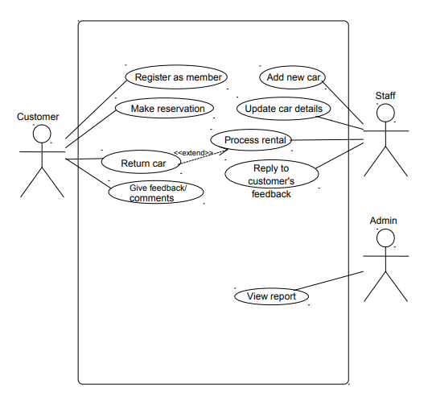

**Fig 3.2: Use Case Diagram**

**Chapter 4**

**4.1 RESULTS/OUTCOME**

**4.1.1Home Page:**

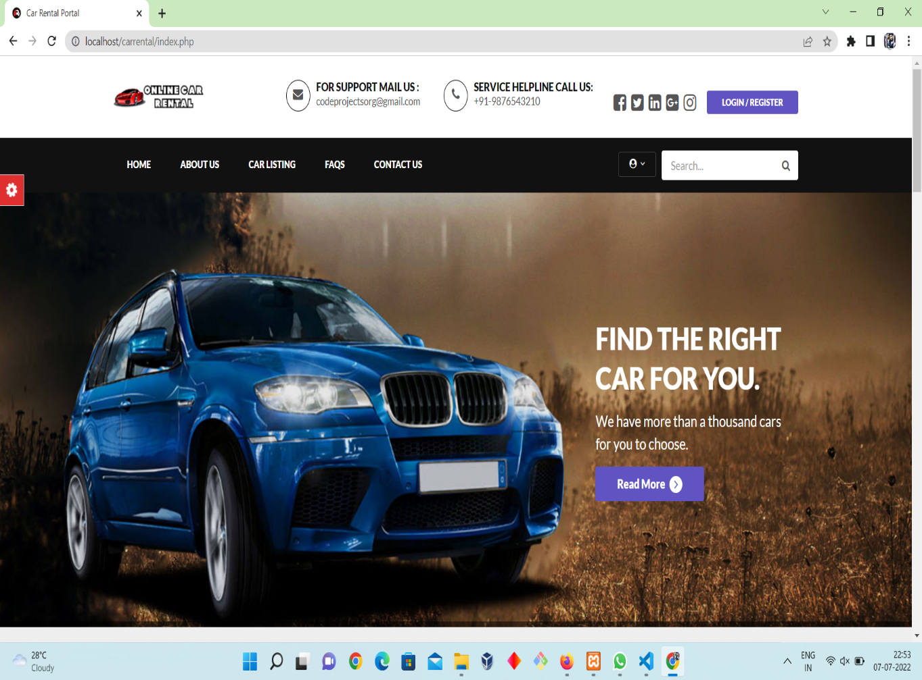

**Fig 4.1: Home Page**

**4.1.2Car Selection:**

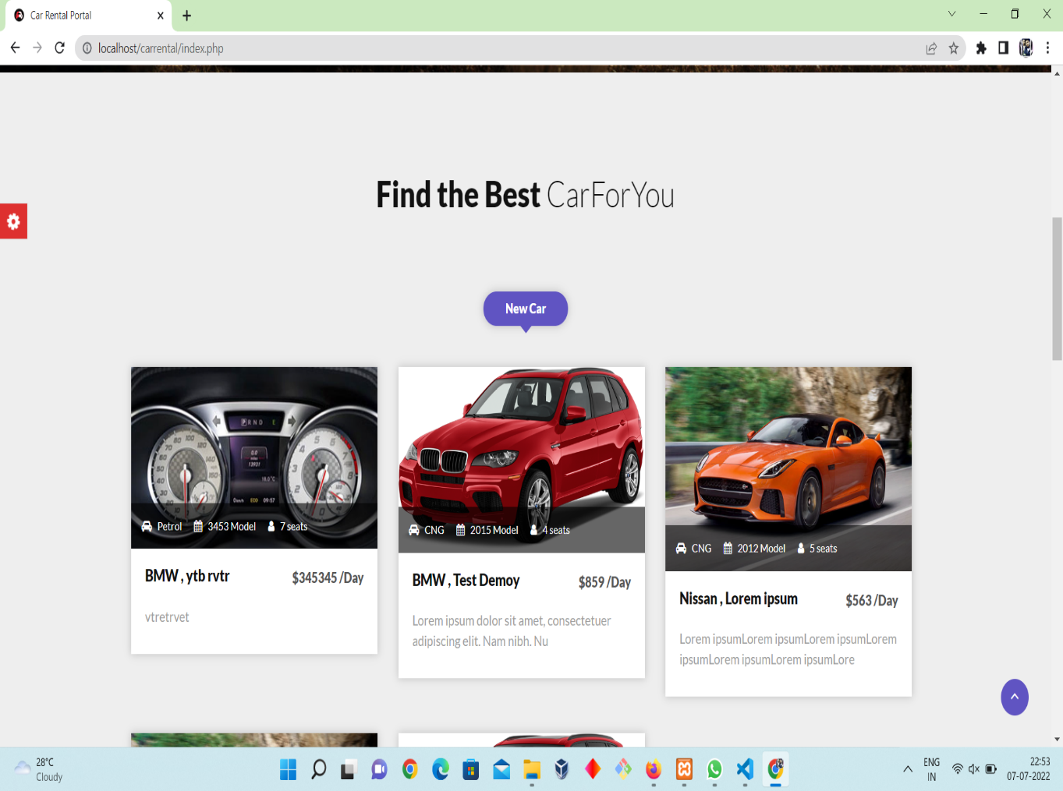

**Fig 4.2 : Car Selection**

**4.1.3Profiles:**

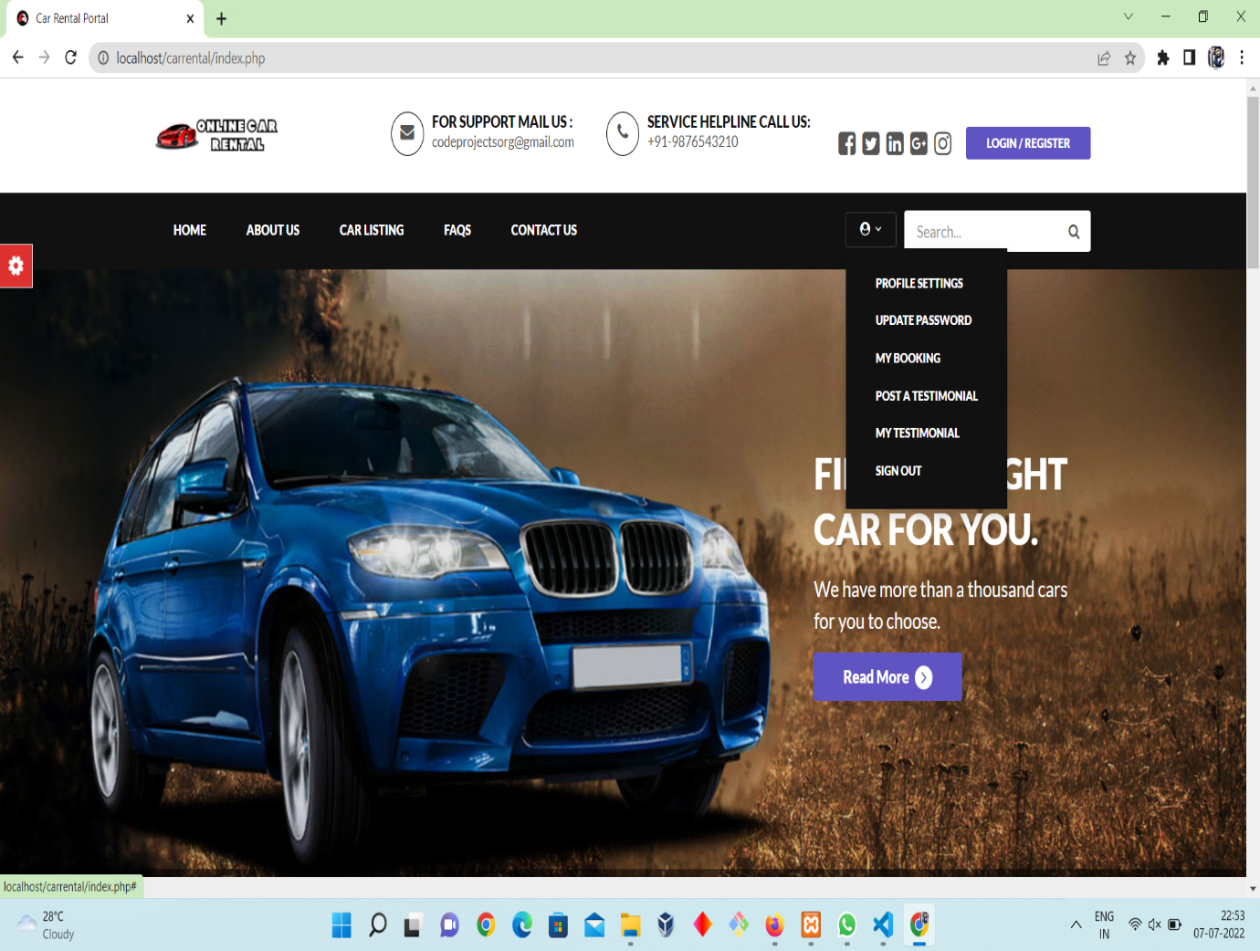

**Fig 4.3: Profiles**

**4.1.4 Register & Login**

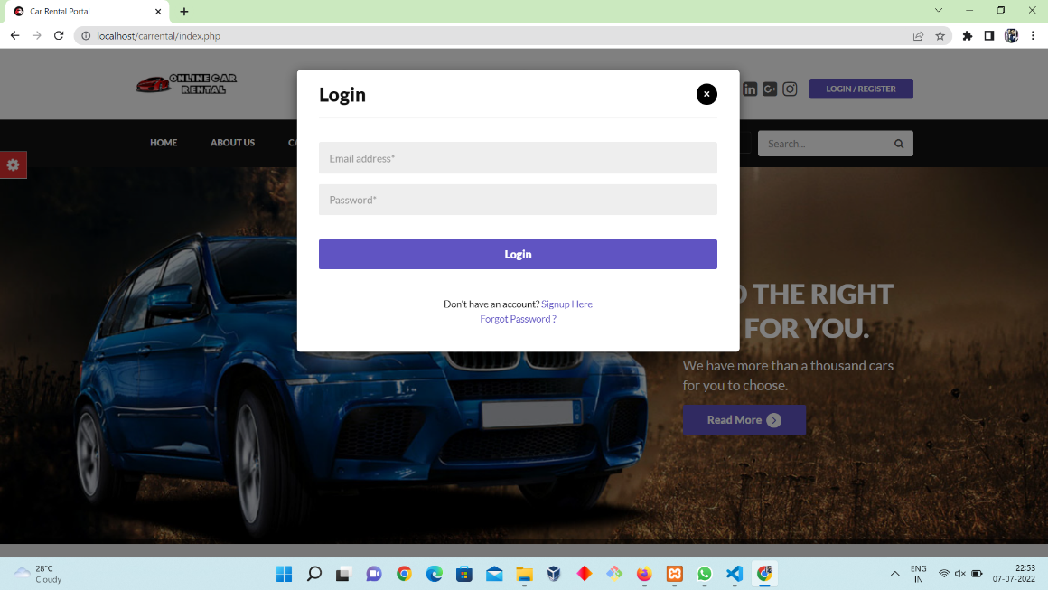

**Fig 4.4: Register & Login**

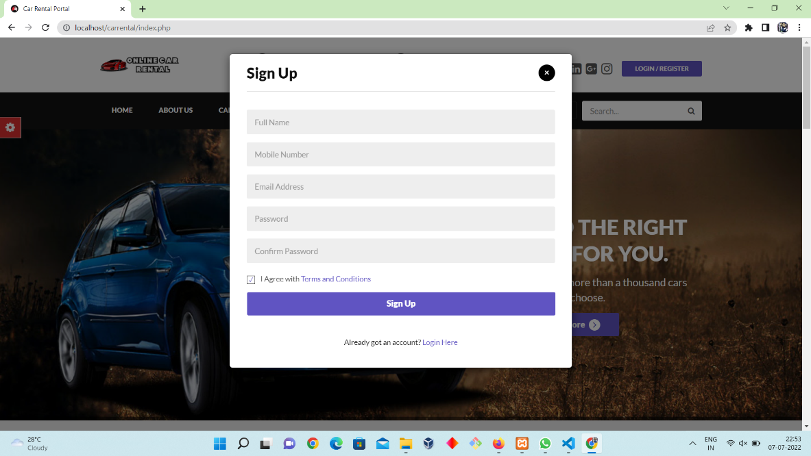

**Fig 4.5: Sign Up**

**4.1.5 Admin Panel:**

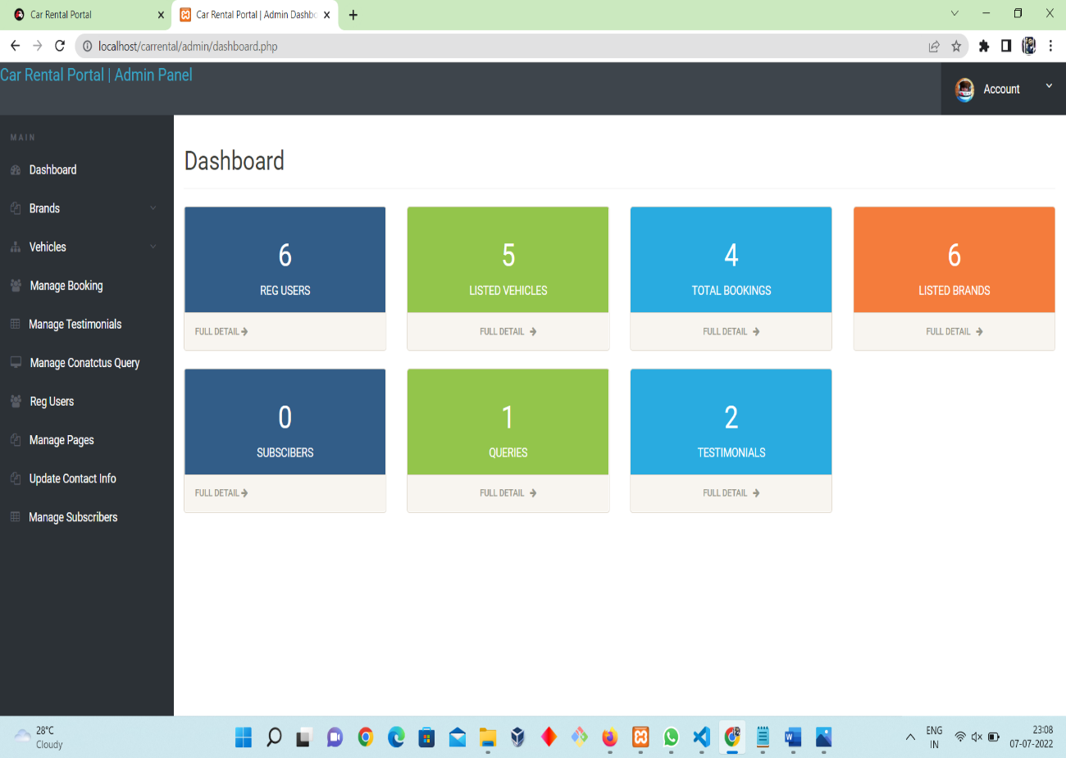

**Fig 4.6: Admin Panel**

**Chapter 5**

**CONCLUSION & FUTURE WORK**

* 1. **Conclusion**

Car rental business has emerged with a new goodies compared to the past experience where every activity concerning car rental business is limited to a physical location only. Even though the physical location has not been totally eradicated; the nature of functions and how these functions are achieved has been reshaped by the power of internet. Nowadays, customers can reserve cars online, rent car online, and have the car brought to their door step once the customer is a registered member or go to the office to pick the car. The web based car rental system has offered an advantage to both customers as well as Car Rental Company to efficiently and effectively manage the business and satisfies customers’ need at the click of a button.

* 1. **Future Work**

As we live in a fast moving world where new technology is introduced everyday and the previous technologies become outdated. Mass population shifts on new technology as they are suitable for fast accessing of the application. As every new edition of book is printed with some modifications and the errors that are made during the previous publication are removed. Same is the case with the modern technology. In every update to the software new functionalities are added for smooth running of the system. It enhances its flexibility and provides interactive interface for the user. Future enhancement of the system will be Accurate positioning of vehicle and designing an algorithm in such a way that each driver must get plenty of trips during his work.

References

1. Car rental website <http://www.carrentingsolutions.com/>

Accessed on 12 june 2022

1. Car rental report,Acadmia,<http://www.imscart.com/car_rental_software.html>

Accessed on 15 June 2022

1. Car Rental business,Fleetroot, [https://fleetroot.com/blog/how-to-effectively-market-your-car-rental-business**/**](https://fleetroot.com/blog/how-to-effectively-market-your-car-rental-business/) **,**15 June 2022
2. PHP variables, W3Schools, [www.w3schools.com](http://www.w3schools.com), 11 June 2022
3. Holzner,S(2008).PHP:The Complete Reference,McGraw Hill Education
4. Nicholas C. Zakas(2010). High Performance JavaScript: Build Faster Web Application Interfaces, O′Reilly, Ist Edition
5. Bresciani, Chiara & Colorni, Alberto & Costa, Francesca & Luè, Alessandro & Studer,Luca.(2018).Carpooling:facts and new trends. 1-4. 10.23919/EETA.2018.8493206.
6. Javascript Functions, Javatpoint, <https://www.javatpoint.com/javascript-tutorial> accessed on 12 june 2022
7. Environementalapproach,Simplearn, <https://www.simplilearn.com/enterprise-environmental-factors-organizational-process-assets-article>, accessed on 16 june 2022